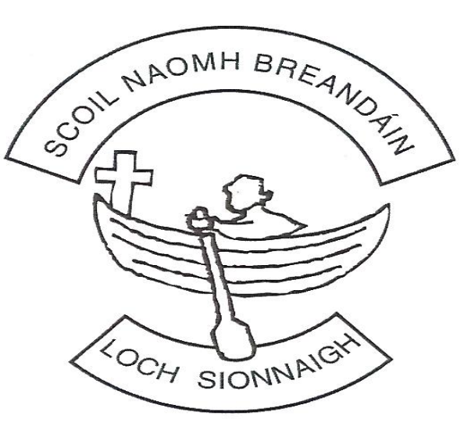

ST BRENDAN'S NATIONAL SCHOOL LOUGHSHINNY
ANNUAL ADMISSION NOTICE
In Respect of Admissions to the 2027/2028 School Year
Roll Number: 16844S
School Address: Loughshinny, Skerries, Co. Dublin
Patron: Archbishop of Dublin

Admission Policy
A copy of the school's Admission Policy and Application Form for Admission for the 2027/2028 school year is available as follows:
- Download from the school website www.loughshinnyns.ie
- By request from the school office secretary@loughshinnyns.ie
- In hard copy from St Brendan's National School Loughshinny, Loughshinny, Skerries, Co. Dublin, K34T853

PART 1 - Admissions to the 2027/2028 School Year

Application and Decision Dates for Admission to Junior Infants
The following dates apply to admission to Junior Infants for the 2027/2028 school year:
Admissions Process | Date
The school will commence accepting applications for admission on | 6 January 2027
The school shall cease accepting applications for admission on | 26 January 2027
The date by which applicants will be notified of the decision on their application is | 29 January 2027
The period within which applicants must confirm acceptance of an offer of admission is from | 29 January 2027 until 4.00 p.m. on 11 February 2027

Supporting Documentation
In order for an application to be considered complete, parents/guardians must submit:
- A completed Application Form.
- A copy of the applicant's Birth Certificate or Adoption Certificate.
- Proof of address where priority based on parish residence is being claimed.
- Any additional documentation requested by the school.
Applications which are incomplete may not be processed.
*Important Notice*Failure to accept an offer within the prescribed period above may result in the offer being withdrawn.
Late applications will be considered in accordance with the school's Admission Policy.

Number of Places Being Made Available in 2027/2028
Class | Number of Places Available
Junior Infants | 28 (1 Class)

PART 2- Admissions to the 2026/2027 School Year
In respect of the 2026/2027 school year:
Admissions Data | Number
Number of places available | 28
Number of applications received | 18
Number of offers made | 18
Number of places accepted | 11
Number of applicants placed on a waiting list | 0

Breakdown of Places Allocated for the 2026/2027 School Year
Criterion | Number of Offers Made
Criterion 1: Siblings (including step-siblings, foster siblings, adopted siblings and children residing in blended family arrangements) of pupils currently enrolled in the school | 8
Criterion 2: Children ordinarily resident within the parish boundaries of Loughshinny Parish | 10
Criterion 3: Children of permanent school staff members | 0
Criterion 4: All other applicants | 0

Declaration
This Annual Admission Notice has been prepared in accordance with the Education Act 1998, the Education (Admission to Schools) Act 2018 and the school's Admission Policy.

Approved by the Board of Management on: ___________________________
Signed: ___________________________________________
Chairperson, Board of Management
Date: ___________________________

School Contact Details
St Brendan's National School Loughshinny
Loughshinny
Skerries
Co. Dublin
Roll Number: 16844S
Telephone: 01-8490394
Email: secretary@loughshinnyns.ie
Website: loughshinnyns.ie
Review Date: September 2027

